Short Sleeve T: Youth Small-Adult XL $9 Adult XXL-XXXL $10
Adult Unisex V-Neck T: Adult Small-Adult XL $12 Adult XXL-XXXL $13 **V-Neck T: Adult Sizing only**
Long Sleeve T: Youth Small-Adult XL $13 Adult XXL-XXXL $15
Hoodie: Youth Small-Adult XXL $20 Adult XXXL $25
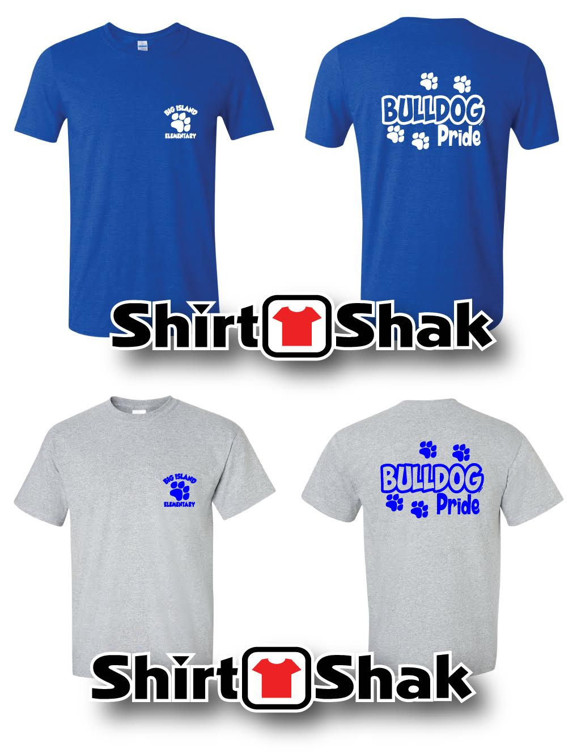

Order forms available from your child’s teacher or in the school office.
Orders and payment due March 31.

